1. 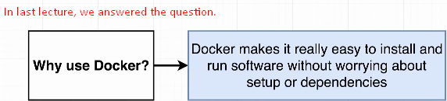
2. 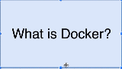
3. 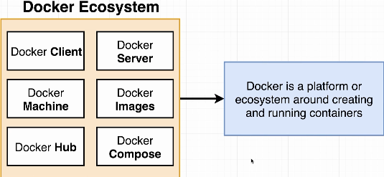 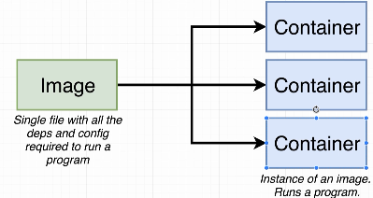
4. What is container? That is the question that we will try to answer throughout the course.
5. When we run the command 🡺 **docker run –it redis** in the last lecture, I went through a little series of actions behind the scenes and we’re going to examine that entire series of actions very closely over time but let me give you two pieces of terminology.  
   When we run the command, something called **Docker CLI** reached out to something called **Docker Hub** and it downloaded a single file called **Image***.*Image is a single file containing all the dependencies and all the configurations required to run a very specific program.  
   **For example**: Redis (specific program) which is what the image I just downloaded was supposed to run. This is a single file that gets stored on your hard drive and at some point in time you can use this image to create something called a container.  
   **Container**: Container is an instance of an image. You can kind of think of it as being like a running program.   
   Container is a program with its own isolated set of hardware resources. So it kind of has its own little set or its own little space of memory, networking technology and hard drive space.   
   We will go into details how it works later.
6. 